league roster – Boys Basketball

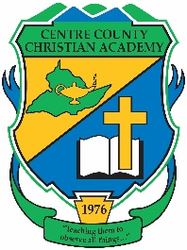

Centre County Christian Academy

Team Colors: Green & Gold

Wins ______ Losses _______ Ties ______

Opponent: ___________________________

Date: ______________________

|  |  |  |  |  |  |
| --- | --- | --- | --- | --- | --- |
| **Number** | **Name** | **Grade** | **Position** | **Height** | **Homeschool** |
| 5 | Ryan Doherty | 11th | Guard |  |  |
| 1 | Mitchell White | 11th | Guard |  |  |
| 10 | Jacob Tlumac | 11th | Forward |  |  |
| 24 | Evan Gore | 10th | Center |  |  |
| 2 | Max Federov | 10th | Guard |  | X |
| 12 | Stephan Kondratyev | 10th | Guard |  |  |
| 14 | Elliot Pimentel | 10th | Guard |  |  |
| 11 | Ben Rossman | 10th | Forward |  |  |
| 0 | Grant Smith | 10th | Forward |  |  |
| 4 | Josiah Pimentel | 8th | Guard |  |  |
| 3 | Daniel Berezhnoy | 7th | Guard |  |  |
|  |  |  |  |  |  |
| 13 | Julian Shvenke | 6th | Guard |  |  |
|  |  |  |  |  |  |
|  |  |  |  |  |  |
|  |  |  |  |  |  |
|  |  |  |  |  |  |
|  |  |  |  |  |  |
|  |  |  |  |  |  |

Head Coach: Rick Gilbaugh

Assistant Coach: Kurtis Gilbaugh

Official ACAA League Team Roster. to be submitted to the scorer’s table before each game.